

**June 2017, E-Newsletter**

**Dennis L. Keschl, Acting Editor**

***Remembering Belgrade High School***

*By Eric Hooglund*

June 2017 marks the 100th anniversary of the Belgrade High School class of 1917. It was a small class, with only five graduates, but that number was one more than the four graduates in the class of 1916!Thanks to the diligent efforts of BHS member Phronie Guptil Hammond, the BHS has in its collection a binder listing the carefully typed names of every BHS graduating class from 1908 to 1969. Thus, we know the names of the five graduates in 1917: Roy Frank Albee, Mildred Villa Dalton, Marguerite Osmond Leavitt, Rowena Allen Wadleigh, and Ernest Joseph White. Readers familiar with the 19th century history of Belgrade will recognize the surnames of four old Belgrade families in that class: Albee, Dalton Wadleigh and White. One of the 1917 graduates, Ernest White, may have been the younger brother of Florence Annie White, class of 1915, and a big brother of Theresa Bridget White, class of 1920. If any member can confirm these possible sibling relationships, the information would be greatly appreciated!

As a helpful clue, we do know that Florence White married Ormand Stevens in 1919. We also would welcome any other information about the 1917 grads, such as how many stayed in Belgrade after graduating and what occupations they pursued. The binder cited above also provides in parentheses the married name every woman graduate. Thus, we know that Mildred Dalton married a Buzzell; Marguerite Leavitt married a VanLeuwee; and Rowena Wadleigh married a Hopkins.

Belgrade’s first high school opened in 1904 in Belgrade Depot, in the former grade school building on the hill close to Depot Road, which is now owned by Cedric Young.

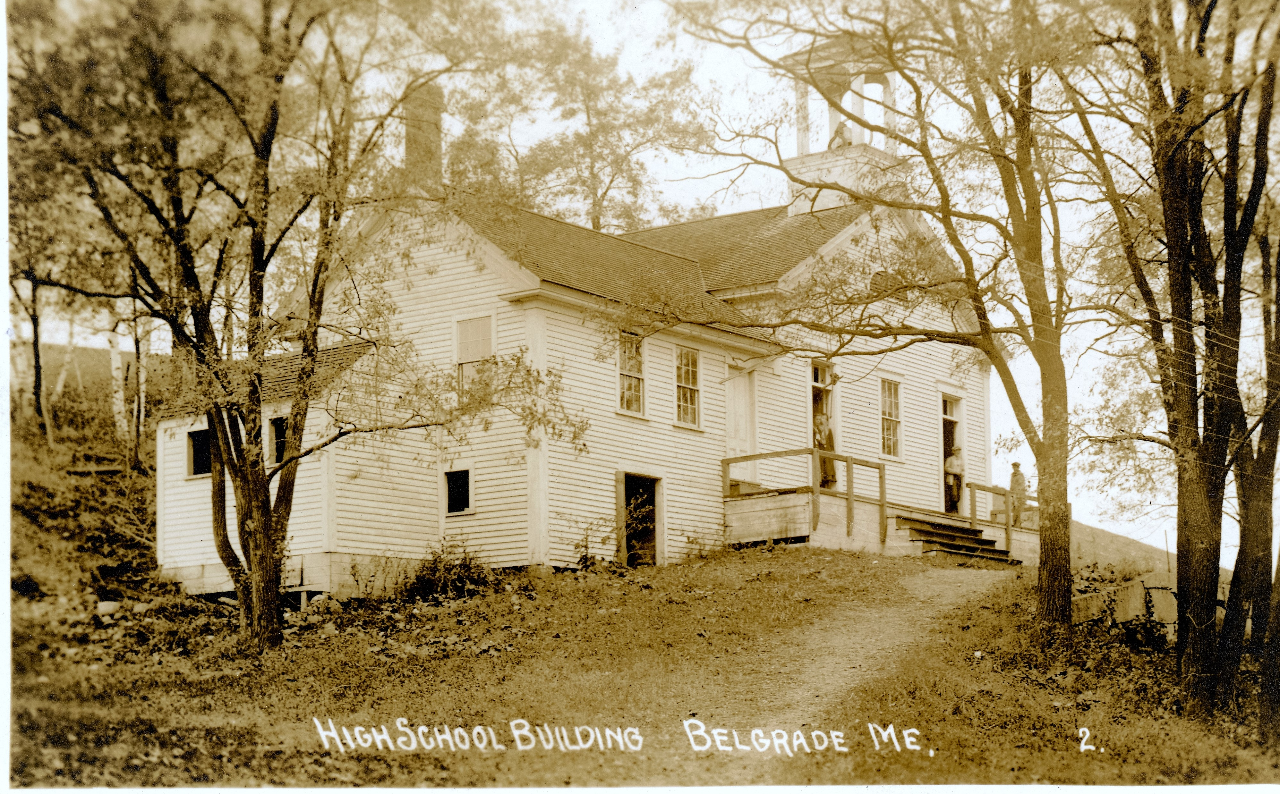 The first class to graduate was that of 1908, and with 23 students receiving diplomas in that historic class, it remains the largest graduating class in the 65-year history of Belgrade High School. The original high school continued to serve the Belgrade community for 15 years.

A new, two-story consolidated Central School was built in Belgrade Depot during 1922-23. Construction was completed in the spring of 1923, with the lower floor being for the grade school, and the upper floor for the high school. Maine’s then-governor, Percival Baxter, and other state officials came from Augusta for the dedication of the new school

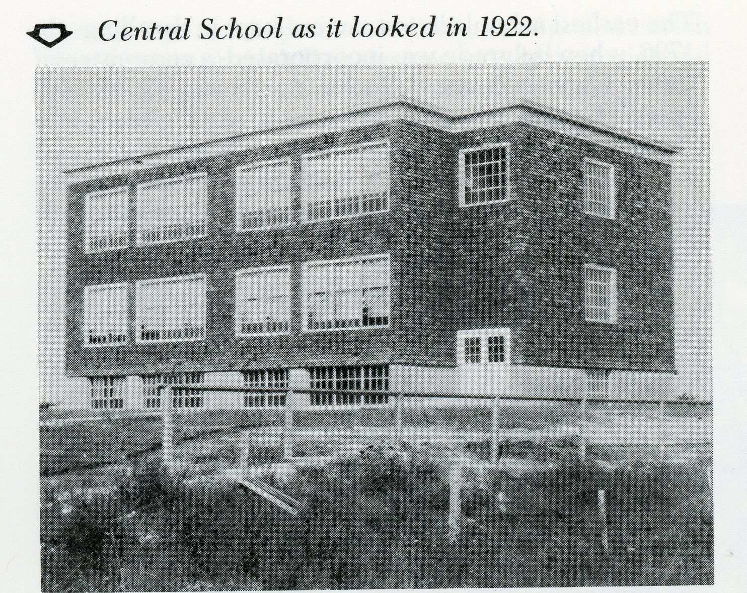

The original Central School burned in a fire that broke out on a cold winter day in February 1943. Belgrade’s high school students were scattered to nearby high schools in Augusta, Oakland and Waterville for the remainder of the school year, but 18 seniors reunited for a graduation ceremony at the Belgrade Grange Hall in June 1943. The Grange also served as a temporary high school in the fall of 1943, while construction of a new Central School was being completed.

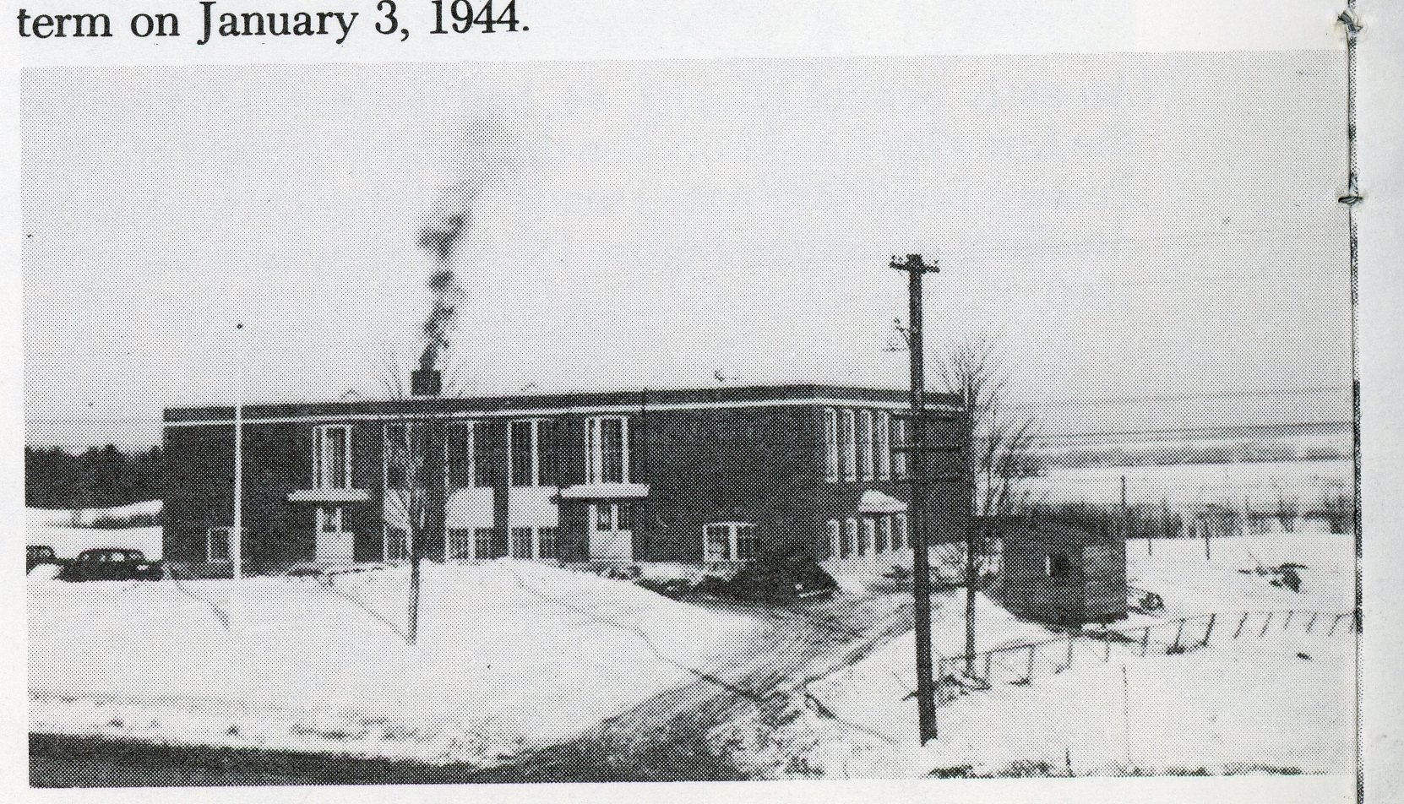In January 1944, the high school students moved into their new classrooms on the second story of the rebuilt Central School.

However, the graduating class of 1944 was one of the smallest—only 4 students, as some students had decided to stay in the high schools to which they had been relocated in February 1943, while several boys had left to serve in World War II as soon as they turned 18 but before completing high school.

Belgrade High School continued to serve the community for 25 more years. However, because the total number of its high school students in all four grades never reached 100 in any school year, after 1960 it was among many small high schools that the State’s Department of Education encouraged to unite with larger high schools. Belgrade High School’s last graduating class was in 1969.

That same year, Belgrade became part of a school administrative district which includes the more populous town of Oakland, and since then Belgrade students of high school age have been attending Messalonskee High School in Oakland.

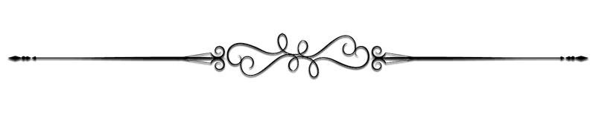***Another interesting article gathered by one of the Belgrade Historical Society Members, is about the Camp Kennebec Reunion recently at the North Belgrade Community Center***

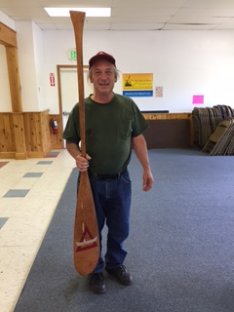 Camp Kennebec on Salmon Lake in North Belgrade was a legendary boys’ camp from 1907 to 1992, and on Wednesday, June 14—110 years after it first opened, several former campers and counselors met at the North Belgrade Community Center on Route 8 to reminisce about their experiences of the Kennebec Ethos.

The Belgrade Historical Society staff assembled photographs, yearbooks and other memorabilia from its Camp Kennebec collection and displayed them in the NBCC for the occasion.

Camp Kennebec alumni Bruce Trumper brought along from his own private collection a Camp Kennebec canoe oar that his own grandfather made over 50 years ago. Bruce’s grandfather and also his father were Camp Kennebec alumni.

Here is a photo of Bruce Trumper holding the special oar is. (Note: the Camp Kennebec insignia is painted on the oar.)

***There is still an outstanding $*100** **reward** for the oldest photograph for the Old Townhouse…see poster below for more information.

**Oldest Photograph of the**

**OLD TOWNHOUSE**

One of the oldest extant buildings in Belgrade is the Old Townhouse on Cemetery Road beside the Woodside Cemetery. Built in 1815 and in use as the location of the annual Town Meetings until 1873, the facility has a long and interesting history.

Dennis “Denny” Keschl, Chair of the Belgrade Historical Society’s Board of Directors, has been researching this historically significant building. One thing he’s not been able to find is a photograph showing the building without the front porch, which was added in the early 1940s. With his deep interest in the Old Townhouse, Denny is personally putting up a prize of $100 for the oldest known picture of the building prior to the porch’s addition.

If you have an old photograph of the Old Townhouse, please send us a copy with descriptive information to verify its provenance to:

Belgrade Historical Society

P.O. Box 36A

Belgrade, ME 04917

After reviewing the photo and information, our Collections Committee will make a determination as to which photograph will win the reward. All entries must be received prior to June 30, 2017. If more than one copy of the winning photograph is submitted, then the one that we receive first will be the winner. The society will keep copies of all the entries submitted for our use. If an original is submitted, we will make a copy and return the original unless it was given as a donation. The reward will be made immediately after the oldest photograph is selected. If you have any questions, please contact Denny at: keschl@yahoo.com tel: 207-495-2973 ~ cell: 207-441-3701

***Remember***, as we research issues that may be of interest to our membership and others, please know that we want your input on topics of historical interest that you would like to see in our newsletter.

***Do you have a particular subject that you believe might be of interest to others?***

If so, please pass on the information to us by simply replying to the e-Newsletter. We will work to research the issue to develop an article on the subject. Better yet, if you have written on a topic that you believe might be of interest…send that along as well!

We want this newsletter to be educational, entertaining, and oriented to the topics about which our readers want to learn. Finally, we want your feedback. If you see something that is inaccurate in the information that we provide…let us know! We will be establishing a ***“Member Feedback”*** column in the upcoming issues and want to hear from you about what you liked or didn’t like about your e-Newsletter.

**\*\*\*\*\*\*\*\*\*\*\*\*\*\*\*\*\*\*\*\*\*\*\*\*\*\*\*\*\*\*\*\*\*\*\*\*\*\*\*\*\*\*\*\*\*\*\*\*\*\***

**Remember…history not recorded is history lost!**